Communications and Resilience COVID Briefing

30 March 2022

Scottish Government News Briefing

Positive cases up by 9,610 since yesterday.
As of 07:30 this morning, 4,353,991 people have received their first dose of a COVID-19 vaccination, 4,092,791 have received their second dose, and have 3,451,131 received a third dose or booster
34 patients who tested positive have died since yesterday.
This makes the current total of deaths in Scotland 11,393.

There are 2,344 patients in hospitals who have been diagnosed/suspected to have the virus (decrease of 39), including 20 patients who are being treated in intensive care.
https://www.gov.scot/coronavirus-covid-19/

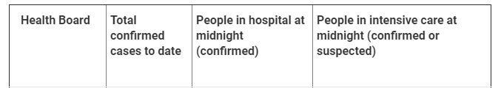
NHS Highland 83,387 135 *

7 day positive rate for neighbourhoods Highland area

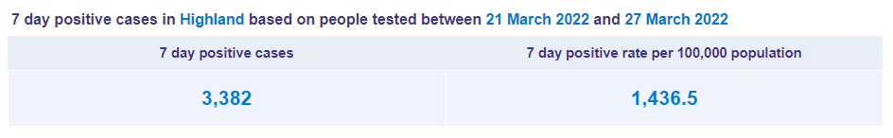

Scottish Government Media Briefing

Key points

- Scotland's last remaining Covid regulations - over the wearing of face coverings - will be lifted in two separate phases.
- From next Monday, 4 April, it will no longer be a legal requirement to wear a face covering in places of worship or while attending a marriage ceremony, a civil partnership registration, or a funeral.
- Then on 18 April the legal requirement will be dropped from shops, public transport and other indoor settings.
- Until then it remains mandatory to wear face masks on public transport, in shops and in other indoor settings
- From these dates, the wearing of face coverings will become a matter of guidance, but Scottish Government will still encourage their use in certain indoor places.

Public Health Scotland Stats - COVID-19 in Scotland: Overview
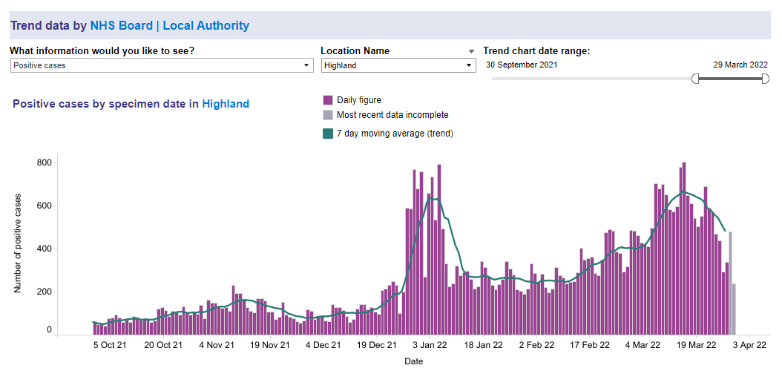
Press Releases Issued by SG today
- Update on COVID-19 regulations

Scottish Government Social Media Messaging
- Unwell with #coronavirus and need medical advice? From Friday 1 April, you should contact your GP practice. If your GP practice is closed, call NHS24 on 111.

UK Briefing

558,732 people tested positive reported over the last 7 days.
1,070 deaths within the last 7 days.
365 coronavirus patients in hospital beds with a ventilator on 29 March 2022.
165,187 total number of deaths recorded, 28 days from first positive test for COVID-19 reported, updated 30 March 2022.
52,792,930 people had been given a first dose by the end of 29 March 2022.
49,415,450 people had been given a second dose by the end of 29 March 2022.
38,791,373 people had been given a third / booster dose by the end of 29 March 2022.

UK Government Media Releases

- Government sets out next steps for living with COVID
- Changes to COVID-19 testing in England from 1 April

NATIONAL ISSUES

- UK: When will free Covid tests end across the UK and can I buy LFTs?
- Scotland: End of Scottish face mask rules delayed until Easter

The Corporate Comms team continue to share pertinent advice from other agencies and Govt departments through social media, including warnings about scams, mental health wellbeing and resources for pupils.

As restrictions are eased, the emphasis will continue to be on personal responsibility, good practice and informed judgement. The latest information on Coronavirus in Scotland can be accessed at: Coronavirus in Scotland - gov.scot (www.gov.scot)

